3. Using CTEs and Recursive Queries
A Common Table Expression (CTE) is essentially a temporary result set of a query that can be used in a subsequent query to simplify complex query processing. In this exercise you will learn how to create and use queries involving CTEs.
Perhaps the most useful application of a CTE is for retrieving hierarchical data. Two common business examples of hierarchically organized data are: (a) the manager-subordinate relationship in an employee hierarchy, and (b) the product-component relationship in a production bill-of-materials. In this exercise you will learn how to use recursive T-SQL CTE queries for this purpose.
Before getting started in the readings and code snippets, let’s try to find the starting point of the employee hierarchy. What I want you to do is try to determine who is the boss of all bosses at AdventureWorks. You should be able to find the name of this person using these two tables:
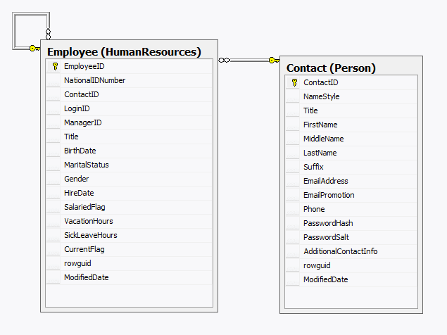
A. Write the query to produce the employee ID, employee title (i.e. job position title), and first and last names of the person who is the big boss at AdventureWorks. Note: in this query you cannot make any assumptions of what the job title should be. There is a better way to figure out who’s the big boss. Store this query in a file named Exercise 3A.SQL. Below, write these values:
Employee ID:
Title:
First and Last Names:

Now that you have determined the head honcho at AW, read this article about CTEs.
http://facility9.com/2008/12/09/a-quick-introduction-to-common-table-expressions

Answer the following questions:
There are five different queries in this example. The first and second are a non-CTE and CTE version producing the same results (very simple). The third and fourth are a non-CTE and CTE version producing the same results (more complex). The fifth is a recursive CTE query, showing the employee hierarchy.
For each query, execute the query and capture a screen image showing both the query and the results. Paste these in the sections below:

B. Query 1

C. Query 2

D. Query 3

E. Query 4

F. Query 5

G. Fill in the following analogy correctly. One of the blanks will contain “CTE” and the other will contain “View”:
A ________ is to a file as a _________ is to a variable.

H. Could we get the average salary of all the employees of a manager using a recursive CTE? Why or why not?

I. Modify the recursive query so that the name and job title of the employee will show. Hint: this involves additional joins in both the anchor and recursive queries, and will also require you to add to the field list of the CTE. Sort the results by EmployeeLevel. This will make the hierarchy easier to visualize. Save this file as Exercise 3I.SQL. The results should look like this, with a total of 290 rows:
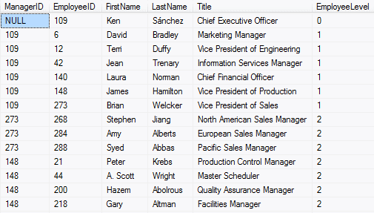

J. Now, modify it further so that the name and job title of the manager is also showing. Therefore, you should see both manager and employee names and titles. This is a tricky one. Part of the trick in the recursive query is to figure out where you’re getting the manager name and title. Save this file as Exercise 3J.SQL. The results should look like this, with 290 rows:
